ASTRonomy 112

Laboratory Manual

Fall 2005

Department of Physics and Astronomy
George Mason University

Table of Contents

LABORATORY SAFETY AND CONDUCT RULES 5
1 Mathematical Tools 7
2 The Celestial Sphere 27
3 Kepler’s Laws of Planetary Motion 37
4 The Revolution of the Moons of Jupiter 45
5 Optics of Cylindrical Mirrors and Lenses 51
6 Retrograde Motion of Mars 59
7 Geological Features of Mars 65
8 Cratering in the Solar System 73
9 RADAR and the Rotation Rate of Mercury 79
10 Finding an Asteroid 87
MAKE-UP> A Planisphere 105

Laboratory Safety and Conduct Rules for Astronomy Laboratory

- No student is permitted in the laboratory without an instructor.

- Students may not start an experiment until given permission by the instructor.

- Students may not block the aisle in the laboratory with their bags, jackets, notebooks and other articles. Laboratory aisles must be kept uncluttered.

- Bare feet and sandals are not acceptable.

- No student may invite individuals who are not enrolled in the Physics/Astronomy laboratory courses to come in the Physics/Astronomy laboratory class.

- No student is permitted to change the configuration of any computer he/she is working on and will only use the computer as instructed to work on physics or astronomy laboratory experiments.

- Absolutely no eating or drinking in the laboratory during anytime.

- Every student will clean up his/her work area before leaving. This includes any gum wrapper, paper confetti or eraser crumbs which accumulates during the lab session.

- No student will write on or deface any lab desks, computers, or any equipment provided to them during the experiment. They will use all equipment only for the purpose intended.

- I have read and understood these rules. I understand that any violation of these rules could lead to dismissal for the lab session and any other appropriate action by the instructor.

Signed: _____________________________________ Date: ______________

Printed Name: _____________________________ Lab Section: __________________

Laboratory Exercise #1 - Mathematical Tools

Purpose: Review mathematical concepts, especially algebra and scientific notation, that are part of the quantitative techniques used in astronomy. Also, review the use of computer spreadsheets in the routine analysis and graphing of astronomical data.

Introduction
Astronomers ask questions about the objects they observe. To answer many questions, such as those related to distance, size and velocity of the objects in space, requires mathematical calculations. Today, astronomers rely on computers to perform calculations and display or graph their data. For this and ensuing laboratory exercises, you are required to have mathematical skills at the level taught in high school. This includes algebra and some geometry. You are also expected to be able to utilize computer software, such as a spreadsheet, to assist in the display and analysis of astronomical data.

Graphing
The ability to read and interpret graphs is part of scientific and quantitative reasoning. This is essential to understand how science, a well defined process, is accomplished. In this laboratory exercise, and many of the following exercises in the reminder of the semester, you will be asked to plot or graph certain data. You will then need to extract information from the graphs. This requires you to understand the basic nature of the Cartesian plane, namely the xy-axes of a graph. Please keep in mind that proper units are always necessary, so always label your data, label your graphs, and note the units you are using in your calculations.

There are many different types of curves that can result from the graphing of data. Some graphing will entail the plotting of data which is linear, that is, the result will be a straight line. Each point on a line can be defined by two values, an x-value and a y-value. Each line can have a positive or a negative slope, that is, the line will either slant upward or downward as it moves to the right. This means that y will either be a positive or a negative multiple of x plus a constant offset. For example:

y = c₁x + c₂

Here c₁ and c₂ are constants. If c₁ = m and c₂ = b, the equation then becomes the standard slope-intercept formula of a line:

y = mx + b

Here m is the slope of the line and b is the y-intercept or the point where the line crosses the y-axis.

Please remember that a line can have a slope of zero, meaning it is horizontal, or no slope, meaning it is vertical.

You will encounter plots that are not linear. In such a case you will have to graph the values of x and y so that the shape of the resulting curve can be determined. Nonlinear equations, associated with non-linear plots, are more difficult to solve.

Procedure
On the desktop open up the folder named “Excel Files,” and open the file named “graph_sample.xls.” If this file is not on your computer, it can be downloaded from the following ftp site: ftp://physics.gmu.edu/pub/ASTR112_14/excel/
When you open the file it should appear similar to the screen depicted in Figure 1.1.

Figure 1.1: Screen Capture of Excel File
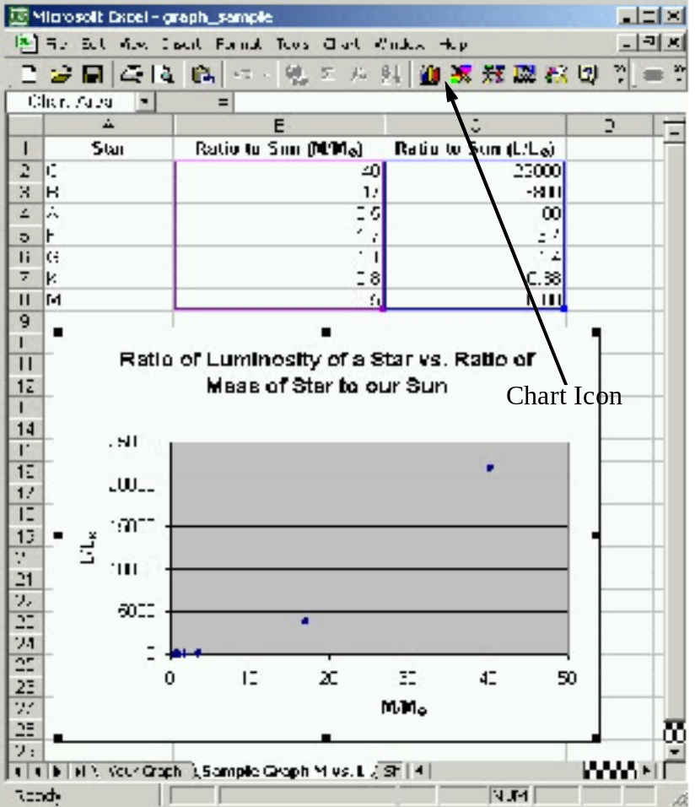

The values in the first column represent the ratios of the masses of certain stars to the mass of the Sun. The values in the second column represent the ratios of the luminosities of these stars to the luminosity of the Sun.
The columns of data labeled ‘Ratio to Sun (M/M)’ and ‘Ratio to Sun (L/L)’ are highlighted, indicating that data in these columns were used in developing the graph. The Sample Graph was created using the ‘Chart Icon,’ indicated in Figure 1.1.
Using your mouse, click on any number in the ‘Ratio to Sun (L/L)’ column. Look at the “Equation Line,” which is beside the equal sign, and the “Active Cell” indicator. Their locations are marked in Figure 1.2. You will notice that when a cell is clicked on, or activated, the cell value is shown on the equation line.

Also, notice that the active cell is shown as B2, i.e. Column B, Row 2. The equation line tells us how B2 is calculated. In this example, the number ‘40’ has been typed into the cell. However, rather than simply typing a value in a cell, you can write an equation that will generate a solution using inputted data. We will examine this feature of Excel next.

Figure 1.2: Equation Line and Active Cell Locations

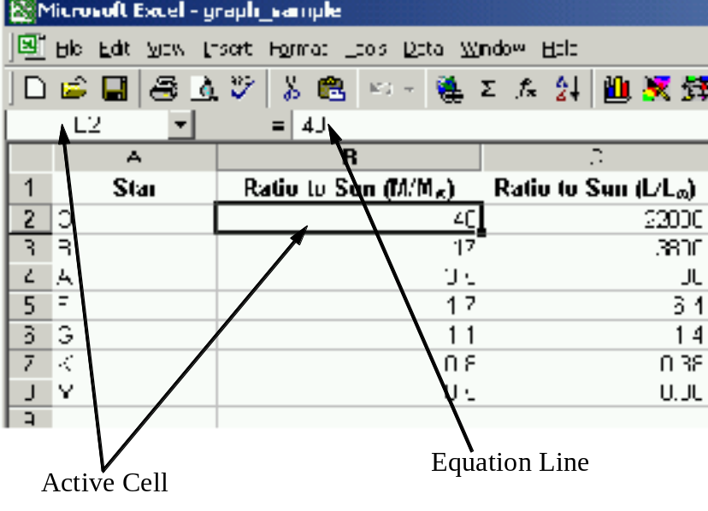

- Look again at Figure 1.2. At the bottom of the Excel screen you will see two tabs, one labeled 'Your Graph' and the other labeled 'Sample Graph M vs. L.' You can toggle (i.e. go back and forth) from one worksheet to the other by clicking on these tabs.
- Return to the ‘Sample Graph M vs. L’ worksheet. You’ll notice that the shape of the data graphed in this worksheet does not appear to be linear. We want to re-graph this data in a way that will produce a linear relationship. This can be accomplished by doing the following: Take the logarithm of the two columns of data that were provided. Plot the logarithms of the Mass Ratios on the x-axis and the logarithms of the Luminosity Ratios on the y-axis. This will result in a linear relationship.

Note: The logarithm of a number is the power to which 10 must be raised so that it equals the number. For example, the logarithm of 100 is 2, because 10 raised to the power of 2 (i.e. 10 × 10 = 10²) equals 100. Use your calculator to find the logarithm of 50 and check your answer by raising 10 to this power. Powers (i.e. exponents) are discussed later in this lab.

Excel can be used to calculate the logarithm of a number. Instead of simply typing a value in a cell, you would type in an equation, much as you would do on a calculator. When using Excel, however, you must insert an ‘=’ sign before the equation.

Example: You want to calculate “x times y.” (Column A contains your x-values and column B contains your y-values. The heading [i.e. name] of each column would be in the first cell of that column.) Therefore, in the cell in which you want the answer, type ‘=a2*b2.’ (The letters can be capitalized.) The numbers in the cells A2 and B2 will be multiplied together and their product will be given in this cell as the answer. So, if the number in cell A2 = 5 and the number in cell B2 = 7, then the value in the cell with the equation would be 35.

Assignment: Find the logarithms of the data provided and graph the resulting columns of data.
Τo begin, an equation must be entered into Excel that will calculate the logarithm of the values provided. The function ‘log’ in Excel means ‘take the logarithm of.’ Therefore, to take the logarithm of the value in B2 and place the answer in D2, type the following in cell D2:

=log(B2)

When using Excel to make a calculation, remember that you must type an ‘=’ sign in the cell before the equation. (You may want to check the value with a calculator to ensure that your equation is correct.)

Instead of typing the same equation in each D-column cell, you can simply highlight and copy the equation. Excel will then automatically calculate all the logarithm values. This procedure is further explained below.

How to Copy Cells in Excel:
Click on the cell D2. Notice that the mouse image changes from an arrow to a cross. Move your mouse to the lower right-hand corner of the cell, and the mouse image will change from a wide cross to a thin, black cross. When the black cross appears (i.e. ‘+’), click and hold down the left mouse button and drag the cross down the column to row 8, since B8 is the cell containing the last ratio value provided. When you let go of the mouse button Excel will “copy” the equation in each cell, advancing the cell address provided in the equation, and calculate all the values. All the cells should now be filled with the converted (i.e. logarithm) values.

- Repeat the same procedure for the ratio of the luminosity of the stars to the luminosity of the Sun using the conversion equation, placing the logarithm values in column E.
- Remember that all the Luminosity Ratios are located in column C. Therefore, for the first cell E2, you will refer to the luminosity given in cell C2. Continue as above, checking the Excel value and copying the equation to the other column-E cell locations.
- A graph can now be made using the logarithm values in columns D and E.

How to make a Graph in Excel:
To begin we must use the mouse to highlight the data we want to graph. Whatever data is highlighted first will be entered as our x-values and the data that is highlighted next will be entered as our y-values. Therefore, since we want the logarithm of the mass ratios on the x-axis we must first highlight the data in column D. While holding down the left mouse button, drag the mouse from D2 to D8. (Notice that when you let go of the mouse button the column background changes to blue.) Now, go to column E and while holding down the Ctrl key, highlight the values in this column. Both columns should now be highlighted.

- Click on the Chart Icon in Excel. Select the ‘XY (Scatter)’ graph. Title your graph (i.e. give your graph an appropriate name) and label your axes. (Your instructor will guide you through the process of constructing a graph in Excel with the aid of a projected computer-screen image.)
- Print out the data table and your graph. This can be done together, in one step. First enter your name in an open cell underneath the data table (or in some other appropriately-located cell). Highlight the data table and the area under your graph (i.e. the area that your graph is covering). Go to File-Print Area-Set Print Area. Now that the print area has been set, select File-Print Preview. Make sure that the data table and graph fit on one page. If everything is shown in its entirety, click Print. Your copy can be retrieved from the printers located opposite the elevators, (down the hall and) just to the left of this room. You will need Mason Money on your ID card to retrieve your printed material.
- Keep this print-out and submit it with the rest of your work at the end of class. Examine your graph. Does your data appear linear?

Linear Equations Review
In the above example we were able to graph a line even though the equation which produced the line was not known. Many of the data sets with which we will work will exhibit a simple linear relationship.

Linear equations are of the following general form:

y = mx + b

If the values of m and b are known, y can be solved for a given value of x. Alternatively, if the value of y is known, the equation can be solved for x. This would require rearranging the terms in the equation:
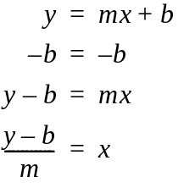

We have changed the form of the equation simply by subtracting from each side, or by dividing each side by, a different term at each step. The equation is now solved for x, as x is isolated on one side of the equal sign.

As with any equation, if you add/subtract/multiply by/divide by a value or a term on one side of the equal sign, you must perform the same operation on the other side, so that the two sides will remain equal.

Note: If b = 0, then you only have to divide y by m to solve the equation for x.

1.) Think! What would the graph of the equation y = x look like? (Sketch the graph on the answer sheet at the end of this write-up.)

2.) What is the approximate slope and y-intercept (i.e. the value of b) of the graph you created in Excel? (Find two points on your line and recall that the slope, m, is the rise over the run. Once you find the value of m, you can solve for b. The value of b can also be determined by inspection.)

ALGEBRA and RATIOS
Understanding astronomical sizes and distances can be difficult as they are often so large that they go beyond our everyday comprehension. One way to appreciate the sizes of planets/moons/stars is to construct ratios between these celestial bodies so that sizes can be examined in relation to one other. The question could be asked, “How many times larger/smaller is one object than another?” To answer this question requires that we set up a ratio between the two objects. Let’s try to use ratios to find out about the relative sizes of some of the celestial bodies in our solar system.

Let’s state the question: How many times larger/smaller than the Earth are the following celestial bodies?

Table 1.1: Celestial Objects
Mercury | Jupiter | Sun
Venus | Neptune | Pallas Asteroid
Mars | Pluto | Halley’s Comet

A guess can be made as to the answer you expect. Guess if the object is larger or smaller than the Earth, and remember to record your guesses in Table 1 on the answer sheet provided. You will then be required to determine the exact ratio.

The next step has to do with fact collection, concerning quantities we already know or can easily look up in our textbooks.

1.) The table below gives the approximate radii of the Earth and the celestial objects listed in Table 1.1.

Table 1.2: Celestial Bodies and their Radii
Celestial Body | Equatorial Radius (km) | Celestial Body | Equatorial Radius (km)
Earth | 6,378 | Neptune | 24,764
Mercury | 2,439 | Pluto | 1,123
Venus | 6,052 | Sun | 696,000
Mars | 3,397 | Pallas  Asteroid | 261
Jupiter | 71,492 | Halley’s Comet | 5.2

2.) A ratio is the quotient of two numbers (i.e. there are no units attached to a ratio). It is often written in the form of a fraction. If we want to compare the Sun’s radius to the Earth’s radius, we need to put the Sun’s radius in the numerator and the Earth’s radius in the denominator, as shown below. The quotient will be the number of Earth radii that equals the radius of the Sun.

If the radius of the object under consideration is larger than the Earth’s radius, the resulting ratio will be greater than one. This ratio will describe how many times greater the object’s radius is than the Earth’s radius. If the radius of the object under consideration is smaller than the Earth’s radius, the resulting ratio will be less than one. This ratio will describe how many times smaller the object’s radius is than the Earth’s radius. These ratios provide a quantitative means of examining the relative sizes of various celestial objects.

Note: It is important that all the ratios under consideration have the same quantity in the denominator—in this case the radius of the Earth—so that comparisons of the different ratios can be made.

Now you can answer the question that was posed earlier.

3.) Find the ratio of the object radius to the Earth’s radius for each of the celestial objects in Table 1.2. You can use Excel to calculate these values. Enter these values in Table 2 on the answer sheet.

4.) Answer the following questions about the ratios you calculated:
Which object’s diameter is closest to the diameter of the Earth?
Which object’s diameter is closest to three times the diameter of the Earth?
Which object’s diameter is closest to half the diameter of the Earth?
Which object’s diameter is closest to 5% of the diameter of the Earth?

EXPONENTS
Exponents are an economical way of writing the repeated multiplication of a factor:
a a a = a³

Here we represent repeated multiplication by using a power (i.e. an exponent) of 3, which indicates that you need to use “a” as a factor three times. For example, if a = 2, the above equation above would give an answer of 8; i.e. a³ = 8. The exponent (power) simply indicates the number of times a factor is repeated.

Look at the problem below:

a² a⁵

Let’s write the problem in expanded notation:

(a a) · (a · a · a · a · a) = a · a · a · a · a · a · a = a⁷

Notice that a⁷ simply equals a² ⁺ ⁵.

Notice that the exponent in the answer is simply the sum of the exponents of a.

Thus, to manipulate multiplication of values raised to a power, you simply add the exponents. However, this applies only if the value (i.e. the factor) is the same!

Example: a² · b⁵ does NOT equal ab⁷!

How would you handle division of exponents? (Hint: Multiplication and division are opposite operations. When you multiply values raised to a power, you add the exponents.)
a⁵ = a · a · a · a · a = a · a = a²

a³ a · a · a 1

Notice that a² simply equals a^{5 – 3}.

Notice that the exponent in the answer is simply the difference between the exponents of a.

Thus, to manipulate division of values raised to a power, you simply subtract the exponents. Again, this applies only if the value (i.e. the factor) is the same!

Example: a⁵ ÷ b³ does NOT equal ab²!

Question: What happens to the resulting exponent when the power in the denominator is larger than the power in the numerator? In general, will the value that results from this division be greater than 1 or less than 1?

Having now introduced power rules we can discuss scientific notation, which is the form of expressing a value most often used in the sciences. In this notation a value is expressed as a number greater than or equal to 1 and less than 10, multiplied by a power of 10.

For example, the value 450 expressed in scientific notation:

450 = 4.5 × 100 = 4.5 × 10 × 10 = 4.5 × 10²

You may see this represented on your calculator as 4.5 E2. Here the E stands for exponent and the number raised to that power is always assumed to be 10.

What happens when the value is less than 1?
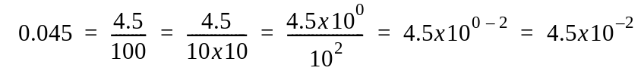

In general, a negative power of 10 indicates a value less than 1.

Now that you can write values in scientific notation, how do you combine values that are expressed in this form?

For addition, the exponents must be identical if we are to add the values preceding them.
(Why is this true?) Think about the values as expressed in standard notation first.

450 + 25 =
We know the answer is 475, but we can get this same value using scientific notation:

(4.5 × 10²) + (2.5 × 10¹) =

Since the powers must be identical we have to change the expression of one of the numbers:

Express 450 as 45 × 10¹

We substitute this expression of the number into the problem:

(45 × 10¹) + (2.5 × 10¹)

You can now factor out the power of 10 by using the distributive law of multiplication over addition:

(45 + 2.5) × 10¹ = 47.5 × 10¹ = 47.5 × 10 = 475

For multiplication, follow the rules for exponential notation as previously discussed:

(450)(1000) =

Express each value in scientific notation:
(4.5 × 10²)(1 × 10³) =
Separately group the numbers and the powers of ten:

(4.5 × 1)(10² × 10³) = 4.5 × 10⁵

In general, multiplication and division problems involving exponents can be simplified. Instead of entering powers of 10 into your calculator, just combine (i.e. add or subtract) the exponents as previously discussed for multiplication and division and then proceed as before.

Many equations used in astronomy contain values which typically are expressed in scientific notation. One example is Wien’s Law, which describes the relation between the temperature of an energy-emitting body and the wavelength of the peak energy emitted. You will be introduced to the theory behind this equation in lecture.

For now, examine the equation:
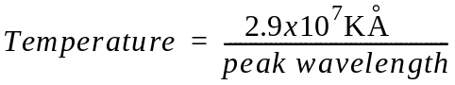
Here Temperature is given in units of Kelvin and peak wavelength is given in units of angstroms.

Answer the following questions on the answer sheet, using Wien’s Law:

1.) If T = 5,000 K, peak wavelength = ?
2.) If T = 2.5 x 104 K, peak wavelength = ?
3.) If T = 3.2 x 104 K, peak wavelength = ?

Now that you know how to work with values expressed in scientific notation, we must emphasize the importance of including a piece of information that is essential when working in any area of science, namely, the unit of measure!

Without units, numbers are simply…numbers! By attaching a unit to a number it becomes a quantity. Units are needed to complete the story of the calculations you made. Were you looking for a velocity, a distance, a time? What does the number represent? Without units you are doing simple mathematical calculations; by attaching a unit, you are making calculations involving velocity, distance, and time, to name just a few quantities. Keep in mind, throughout this lab and this course, that units are important. Not only do they indicate to someone reviewing your work the different quantities that were measured, but, if you pay attention to them as you take your measurements and do your calculations, they also will indicate the algebraic steps you need to follow in order to solve a problem.

IMPORTANT UNIT FACTS
- You can only combine (i.e. add/subtract) two quantities that have the same units.
Example: John walked 1 mile and then walked an additional 3 kilometers. You cannot add these quantities and say that John walked 4 miles-kilometers. In order to do this addition either 1 mile must be converted to an equivalent number of kilometers or 3 kilometers must be converted to an equivalent number of miles.

You can multiply/divide any two quantities, regardless of units; however, just as numbers multiply/divide, so do the units!

Example: John walked 3 kilometers in 20 minutes. If we want to determine the speed at which he walked, we need to look at the following equation:
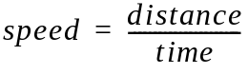
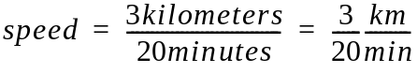

We had to divide both the values and the units.

Units also cancel out like the factors of numbers in multiplication/division problems.

Example: John cycled for 30 minutes at a speed of 15 miles/hour. How far did he cycle?

Notice that this problem involves two different units of time: minutes and hours. We cannot cancel out different units, only identical ones. Thus, we must convert one quantity to the other in order to solve the problem. When converting we want to change the units without changing the value of the number. To do this we will multiply by the value 1 expressed in the appropriate form, since multiplication by 1 does not change the value of a number.

In order to convert 30 minutes into an equivalent number of hours, we will use the following conversion factor, which is a fractional equivalent of 1:

1 hour/60 minutes

Conversion factors are ratios, equal to 1, in which the numerator and the denominator contain different quantities.

You may ask, “How can this help?”

Well, we know that 60 minutes = 1 hour, so let’s try converting the quantity of 30 minutes:

We can see that the minutes cancel out, leaving us with units of hours, which is exactly what we wanted. The conversion factor (1 hour/60 minutes) = 1, because one hour equals 60 minutes. Thus, we have not changed the value of the 30 minutes, but simply converted it to another unit of measure (i.e. to an equivalent quantity).

Now, to solve the initial problem:

John cycled for 30 minutes = 0.5 hours at a speed of 15 miles/hour. How far did he cycle?

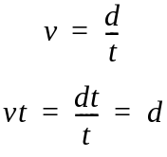
Thus, he cycled a distance d = (15 miles/hour) x (0.5 hour) = 7.5 miles. Notice that we used unit cancellation in both parts of this problem. You will use this technique often in the lab exercises.

Practice with Units and Unit Conversions

1.) It took Karen 500 seconds to run a mile. How many minutes is this?

2.) What was Karen’s velocity, assuming she ran the mile at a constant speed?

PROBLEM SOLVING TECHNIQUES
Let’s use the concepts outlined above to help solve a problem. In astronomy we must ‘use’ mathematics to ‘answer’ a question. Therefore, you must know how to formulate the question into mathematical equations in order to find the solution.

Outline of Steps to Solve Mathematical Questions:
1.) State the question clearly.
2.) Make an educated guess at an answer. This will allow you to check whether your solution makes sense.
3.) Collect the facts presented or needed to solve the problem.
4.) Formulate equations using these facts.
5.) Solve the mathematical problem (i.e. the equations) to answer the question.
6.) Check your solution with your prediction. Ask yourself if it makes sense.

Outlined below is a problem that is typical of those you will be required to solve.

1.) Let’s state the question: How can we determine the way in which a celestial object’s angular size, its actual diameter and its distance from the Earth are related, and how can we use this relationship to determine the diameters of the Sun and the Moon?

2.) A guess can be made about the anticipated answer: Which is the larger of the two celestial objects? Think about the relationship between angular size, diameter and distance. This guess will help you analyze your results. Be sure to include your guess on the answer sheet provided.

3.) The next step is fact collection: What do we already know or what can we easily look up in our textbooks?

a.) The Sun and the Moon have about the same angular size as viewed from the Earth, approximately ½ degree. Angular size is the apparent diameter of an object, measured in degrees.

b.) The Sun is approximately 1 astronomical unit (abbreviated as AU) away from the Earth. An astronomical unit is the average distance from the Earth to the Sun.) The Earth revolves in a slightly elliptical orbit around the Sun.

c.) The Moon is approximately 384,000 km away from the Earth. The Moon revolves around the Earth in a slightly elliptical orbit.

d.) Traveling around a full circle is equivalent to moving through an angle of 360 degrees.

e.) The equation for the circumference of a circle is C = 2πr, where r is the radius of the circle.

f.) Since the Moon’s orbit around the Earth and the Earth’s orbit around the Sun are very nearly circular, we can use a circle to approximate the shapes of these orbits. Thus, we can use the distance values given in parts b and c above as radii values when we calculate the circumferences of these orbits.

Figure 1.3: Arc Length and Central Angle
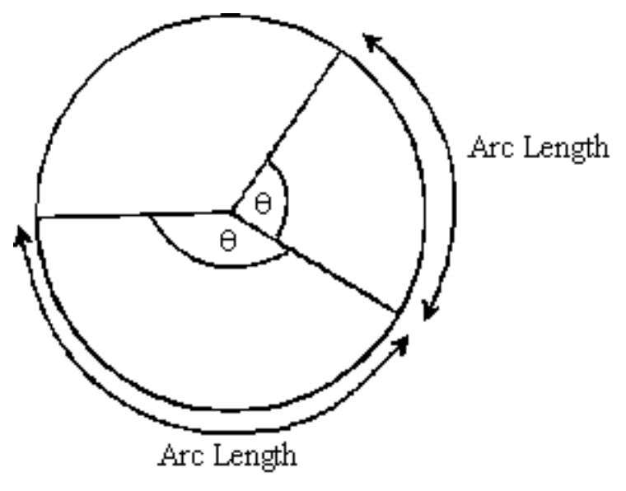

Figure 1.3 illustrates that the larger the central angle of a circle, labeled θ, the larger the corresponding arc length will be. If θ equals 360 degrees, the arc length is equal to the circumference, 2πr. If θ is less than 360 degrees, the arc length will be proportionately less than the circumference.

Figure 1.4 illustrates the relationship between the angular size and the arc length of a celestial object. (Imagine yourself on Earth looking into the sky.) In this diagram, θ is the central angle that represents the angular size of the object. The diameter of the object is just the arc length at the average orbital distance of the object. From the diagram you can see that the arc length is a good approximation for the diameter of the object.

Figure 1.4: Angular Size, Arc Length and Diameter of Celestial Object

4.) Using the above information, we can start formulating equations to solve the problem. We can set up a proportion to demonstrate the relationship between the central angle of a circle and its corresponding arc length:
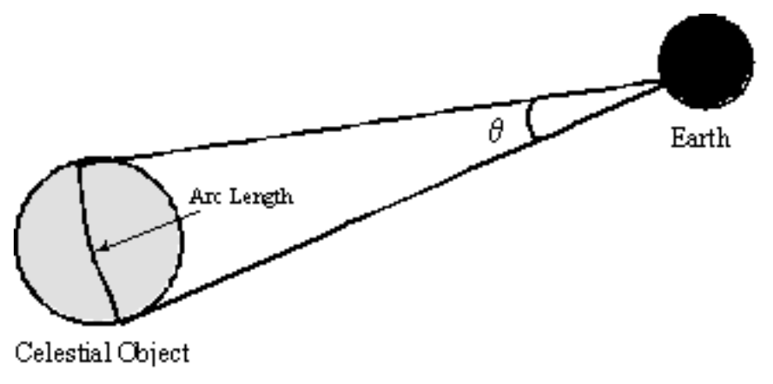

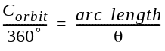

This equation illustrates that the circumference of a circle (C_{orbit}) is to the central angle of a full circle as the arc length is to its corresponding central angle.

Looking at the above proportion we can see that the circumference of an orbit is needed to determine the arc length.

Refer back to the list of facts to find the needed orbital radii and solve for the circumference of each orbit:

C_{orbit Moon} = The circumference of the orbit of the Moon around the Earth

C_{orbit Sun} = The circumference of the Earth’s orbit around the Sun

If you solve the proportion for the arc length, you will have found the approximate diameter of the celestial object:
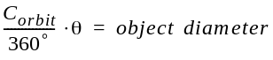

arc length ~ object diameter

Remember that this equation will give the solution in the same units as the circumference of the orbit of the object. Therefore, as always, pay close attention to the units and make sure that the answer you give is in the units requested.

5.) Final answers can now be calculated:
Solve for the diameter of the Sun in units of AU.
Solve for the diameter of the Moon in units of km.
Convert from AU to units of km using the additional fact that 1 AU = 1.5 x 108 km.

6.) Which is larger, the Sun or the Moon? Did the answer match your prediction? How close are the approximate values that you found to the known diameters?

Answer Sheets

To be submitted to your lab instructor.

1.) What would the graph of the equation y = x look like? (Make a sketch below.)

2.) What is the approximate slope and y-intercept (i.e. the value of b) of the graph you created in Excel? (Find two points on your line and recall that the slope, m, is the rise over the run. Once you find the value of m, you can solve for b. The value of b can also be determined by inspection.)

ALGEBRA and RATIOS

- Guesses of the Relative Sizes of Select Celestial Bodies as Compared to the Earth

Mercury |  | Jupiter |  | Sun
Venus |  | Neptune |  | Pallas Asteroid
Mars |  | Pluto |  | Halley’s Comet

- Table 2: Ratio of Radii of Select Celestial Bodies to the Radius of the Earth

Celestial Body | Ratio | Celestial Body | Ratio
Earth |  | Neptune
Mercury |  | Pluto
Venus |  | Sun
Mars |  | Pallas  Asteroid
Jupiter |  | Halley’s Comet

4.) Answer the following questions about the ratios you calculated:

Which object’s diameter is closest to the diameter of the Earth?

Which object’s diameter is closest to three times diameter of the Earth?

Which object’s diameter is closest to half the diameter of the Earth?

Which object’s diameter is closest to 5% of the diameter of the Earth?

EXPONENTS
1.) If T = 5,000 K, peak wavelength = ______________________

2.) If T = 2.5 x 104 K, peak wavelength =___________________

3.) If T = 3.2 x 104 K, peak wavelength = ____________________

IMPORTANT UNIT FACTS
1.) It took Karen 500 seconds to run a mile. How many minutes is this?

2.) What was Karen’s velocity, assuming she ran the mile at a constant speed?

PROBLEM SOLVING TECHNIQUES:
For each problem/question, SHOW ALL WORK, including any calculations needed to answer the question. Clearly list all steps and indicate appropriate units in all your calculations. Be sure to answer all questions posed in the accompanying text.

Guess: Which is larger, the Sun or the Moon? _______________

C_{orbit Sun} = ____________________

C_{orbit Moon} = ____________________

Diameter of the Sun = ____________________AU = ____________________km

Diameter of the Moon = ____________________km

Which is Larger? _______________

Did the answer match your prediction? __________

How close are the approximate values that you found for the Sun and Moon to the known diameters?

Laboratory Exercise #2 – The Celestial Sphere

Purpose: Learn to use a geocentric model of the celestial sphere for purposes of celestial navigation and sky observing. Given any location, date and time on the Earth, find the constellations and stars in the heavens. Given the constellations and stars in the sky at a specific time and date, find the geographic location.

Introduction
The celestial sphere is one type of conceptual model. It models the universe from the point of view that the Earth is the center of the universe. Some ancient astronomers imagined that all the bodies in the universe including the Sun, Moon, planets and stars, are attached to a giant sphere, with the Earth at its center. The stars were thought to be fixed to the sphere while the Sun, Moon, and planets moved along its inner surface. This seemed to be intuitive based upon the simplest observations on any clear night. This model of the universe is not a valid model; however, it is still useful for certain applications.

The geocentric celestial sphere is a handy way of determining the location of various celestial objects. If you look at the appropriate place in the sky, as indicated on the celestial sphere, the desired object appears in your field of view, with or without a telescope.

Until the development of the atomic clock in the late 1960’s, monitoring the positions of the stars on the celestial sphere was an accurate means of timekeeping. The study of the motions of the planets on the celestial sphere was fundamental in the development of Newton’s theory of gravity. The observation of small deviations from the expected positions of some of the planets on the celestial sphere led to the discovery of Neptune. Knowledge of the celestial sphere also permits one's position on the Earth to be precisely determined, something which is of particular importance in navigation.

Getting familiar with Farquhar Globe:
The Farquhar globe is the name given to the globe-within-a-globe mechanical model of the celestial sphere. The outer globe represents the celestial sphere and the small, inner globe represents Earth. Inside the larger celestial globe is a small, yellow ball attached to the end of a long, curved rod. This ball represents the Sun. If you turn the knob to which the rod is attached you can simulate the motion of the Sun through the sky over the course of the year. The path that the Sun traces in the sky is known as the ecliptic.

The metal ring on the stand that circles the center of the celestial sphere is the horizon ring. Look through the transparent celestial globe, past the Earth-globe to the far side of the celestial globe, to view the sky as it would be seen from Earth. The Earth-globe is mounted on an axial rod which is connected to a knob at the bottom of the globe—this is the Earth-knob—which can be turned to rotate the Earth-globe. The rod represents the axis on which the Earth rotates. (The point at which the Earth's axis of rotation connects to the bottom of the celestial sphere is called the south celestial pole. At the opposite end would be the north celestial pole.) The Earth-knob should only be turned in a clockwise direction (as viewed from outside the globe), as if you were tightening a screw. This is the direction in which the Earth actually rotates. (Rotating the Earth-globe in the opposite direction may disassemble the globe.) Rotating the Earth by means of the knob is equivalent to holding the knob and, thus, the Earth stationary, and rotating the celestial sphere. Thus, we can consider the daily rotation of the Earth and the apparent rotation of the stars around the Earth as equivalent motions.

Let’s try to locate some stars on the celestial sphere.

Procedure
Use the celestial sphere to answer the following questions. Note that all questions or problems are repeated on the answer sheets given at the end of this laboratory exercise. Separate the answer sheet pages from this write-up and write your answers on them. This is what should be handed into your instructor.

Please note that the instructions below are for the larger celestial spheres. Unfortunately, there are not many of these left, and the university is only supplying the smaller celestial spheres because of the costs associated with them.

1.) Stars on the sphere are represented by small circles of various sizes. The larger the circle, the brighter the star. What is the name of the brightest star in the constellation of Cygnus? What is the name of the brightest star in the constellation of Lyra?

2.) Other objects such as galaxies and globular clusters are also marked on the sphere. Which globular cluster is located near the constellation of Hercules?

The knob near, but not at, the north celestial pole controls the motion of the sun. This is the sun-pointer knob. Using the appropriate knobs on the sphere, rotate the Earth and move the Sun around the celestial sphere. Notice that the Sun moves along a well-defined line on the celestial sphere. This line is called the ecliptic. The ecliptic corresponds to the plane defined by the Earth's orbit around the Sun. We know, of course, that the Earth orbits around the Sun, but as viewed from Earth, the situation appears reversed: the Sun appears to orbit around the Earth. (When considering the celestial sphere, it is more convenient to think of the Sun as orbiting the Earth) Notice also that the plane of the ecliptic is not perpendicular (i.e. at right angles) to the Earth's axis of rotation. This is because the Earth's equator is inclined by about 23½ degrees to the plane defined by the Earth's orbit around the Sun. (It is this tilt that gives rise to the seasons.)
When you look at the stars, you can see only half of the “visible sky.” The other half is blocked by the Earth. The limit of what you can see is called the horizon. Therefore, the horizon ring represents the limit of what can be seen.

Turn the knob that controls the Earth or rotate the celestial sphere instead. (Remember that rotating the Earth-knob is equivalent to holding this knob and rotating the celestial sphere.) You will notice that sometimes the Sun is above the horizon and sometimes it is below. The time when the Sun is above the horizon is defined as the day, and the time when it is below the horizon is the night. (Although we cannot see the stars during the day because of the brightness of the Sun, the stars are nevertheless still there in the sky. For instance, at the time of a total solar eclipse, the stars will “come out” because the light of the Sun will have been blocked by the Moon.) When the Sun is aligned with the eastern horizon, we have sunrise, and when the Sun is aligned with the western horizon, we have sunset. Over the course of the day, the Sun appears to move from east to west across the sky.

Using the Earth-knob only, move the Sun east to west, from horizon to horizon. Rotating the Earth-knob represents the daily rotation of the Earth on its axis.

When the sun-pointer knob is used to move the Sun, notice that the Sun passes in front of different stars on the celestial sphere. These stars comprise the constellations of the zodiac, with which you are probably familiar. The different positions of the Sun correspond to different times of the year. The Sun will spend an average of about one month in each of the zodiacal constellations. To understand this, think for a moment about the Earth’s revolution around the Sun and consider the diagram below.

Figure 2.1: The apparent change in position of the Sun relative to the stars

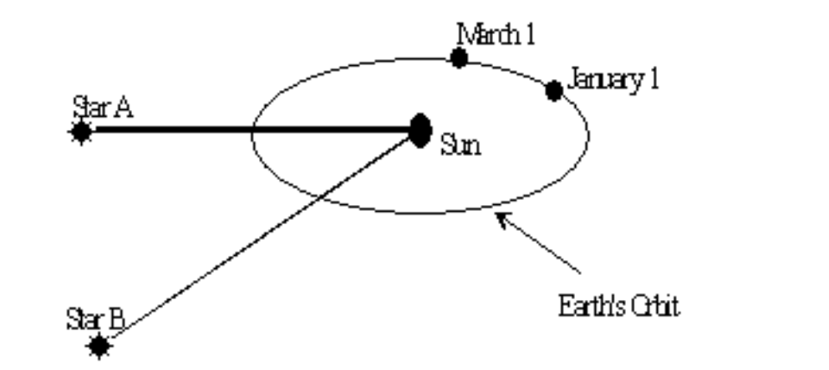

The Earth orbits the Sun once a year. If we could see the stars during the daytime, we would see that on January 1st, for example, the Sun would appear to be positioned near Star A in the sky. As the Earth moves around its orbit, the Sun would appear to move slowly along the ecliptic on the celestial sphere, and would appear to be positioned near star B on March 1st. This apparent change in position is a consequence of the Sun’s apparent yearly motion, not its apparent daily motion of rising and setting. In this way, the Sun would appear to move around the celestial sphere once a year, and each day it would be positioned near a different star.

The path of the ecliptic is demarcated on the globe with small lines that indicate the apparent position of the Sun for each date during the year. Turning the sun-pointer knob changes the date, which corresponds to the location of the Earth in its orbit around the Sun. Adjusting the Earth-knob changes the position of the Sun relative to the horizon, but not relative to the stars. Since the time of day corresponds to the position of the Sun relative to the horizon, turning the Earth-knob changes the time of day. Noon is defined as the time (of day) when the Sun is on the meridian at a given location, which is also the time when it is at its highest point above the horizon for that particular day. The time between successive noons is divided into 24 hours. An hour corresponds approximately to the distance between the lines that connect the north and south celestial poles. These lines are analogous to meridians of longitude on the Earth.

To locate objects on the celestial sphere, we use a coordinate system that is similar to the system of longitude and latitude used to describe positions on the surface of the Earth. Right ascension (the celestial equivalent of longitude, abbreviated R.A.) is measured along the celestial equator. Right ascension is generally measured in units of hours and minutes. On the globe, lines of right ascension are indicated at intervals of 1 hour. Declination (the celestial equivalent of latitude, abbreviated Dec.) is measured in degrees above or below the celestial equator. A declination measure below the equator is preceded by a minus sign. A declination measure above the equator is often preceded by a plus sign. On the globe, parallels (i.e. lines) of declination are indicated at intervals of 15º.

2.1: Example Stars

 | R.A. | Dec.
Betelgeuse | 5h52m | +7º
Vega | 18h37m | +39º

3.) With the definitions given above, fill in the appropriate R.A. and Dec. for the stars listed in Table 2.2. Remember to include the constellation to which the star belongs.

Setting the Globe for a Specific Geographic Location and Time
For the following questions, begin by setting the globe for “noon” at our location, which we will consider as Washington, D.C. Its latitude and longitude are as follows:

Latitude: 39º N Longitude: 77º W

Rotate the celestial globe and the Earth globe until our location is "on top" (i.e. Washington, D.C. should face the ceiling.) Degrees are marked on the meridian ring. To orient the globe correctly, the mark indicating 39º should be positioned at the zenith.

Note: No matter where you are on the surface of the Earth, you can consider yourself as being "on top;" the point directly overhead will be the zenith.

The directions North, South, East and West are indicated on the base (i.e. the stand) of the celestial sphere.

Position the Sun at today’s date.

Set the globe for 12:00 noon by holding the Earth-knob fixed and rotating the sky until the Sun is on your meridian.

Before proceeding, have your instructor check that your globe is set correctly.

4.) Which constellation is closest to the zenith at noon?

5.) Which named star is closest to the zenith at noon?

6.) What is the Sun's altitude at noon?

7.) What direction would you face in order to see the Sun at noon?

To set the globe for other times of the day, remember that the Earth turns 15º/hour from west to east (15º/hour x 24 hour = 360º, which is equivalent to a full rotation). Equivalently, the whole sky moves 15º/hour from east to west. It is easier to simulate the Earth’s rotation by holding the Earth-knob fixed and rotating the celestial sphere.
Rotate the celestial sphere westward until it is sunset (i.e. until the Sun coincides with the horizon ring). As you rotate the sphere, count the number of lines of R.A. that pass under the meridian bar. The number of lines of R.A. through which you have rotated the sky equals the number of hours it is after noon.

8.) How many hours after noon does sunset occur? (Give your answer to the nearest ½ hour)?

9.) What is the Sun's altitude now (i.e. at sunset)?

10.) What direction would you face to watch sunset today?

11.) At what longitude is it now noon?

12.) Is the constellation you found in question 4 still above the horizon at your location? (Indicate totally, partially, or not at all.)
13.) Mirach (in the constellation of Andromeda) and Markab (in the constellation of Pegasus) are two stars that are just rising at sunset. Ask your instructor for the location of these stars on the celestial sphere and then complete Table 2.3. (See the Appendix at the end of this write-up for instructions on how to measure altitude and azimuth.)

Now rotate the sky to 3 hours past sunset.

14.) What are the altitude and the azimuth of the Sun?

15.) Is the constellation from question 4 still above the horizon? (Totally, partially, or not at all.)

16.) Now what are the altitudes and azimuths of the stars in question 13?

Challenge Questions:
17.) It is noon on the 20th of May. You are on a sailboat and you use a sextant to measure the altitude of the Sun. The Sun is to the south and you measure its altitude to be 75°. What is your latitude? Explain your answer.

18.) You are on the same sailboat as in Question 17, but it is now July 5th and it is late at night. You have just been through a storm and all of your maps have been washed overboard. However, being brilliant and resourceful and having taken astronomy at GMU, you realize that all is not lost! You look for the bright star Vega in the constellation of Lyra and find that it is at your zenith. A chronometer (i.e. an accurate clock) on board indicates that it is noon in Greenwich, England.

A.) In what body of water are you?

B.) What are your latitude and longitude? Explain. No credit will be given without an appropriate explanation.

Answer Sheets
To be submitted to your lab instructor.

1.) Stars on the sphere are represented by small circles of various sizes. The larger the circle, the brighter the star.

What is the name of the brightest star in the constellation of Cygnus?

What is the name of the brightest star in the constellation of Lyra?

2.) Other objects such as galaxies and globular clusters are also marked on the sphere. Which globular cluster is located near the constellation of Hercules?

3.) Complete the table below.

Table 2.2: R.A. and Dec. of Stars using the Celestial Sphere

Star Name | Constellation Name | R.A. | Dec.
Arcturus
Sirius
Altair
Pollux
Procyon
Rigel

Setting the Globe for a Specific Geographic Location and Time:

4.) Which constellation is closest to the zenith at noon?

5.) Which named star is closest to the zenith at noon?

6.) What is the Sun's altitude at noon?

7.) What direction would you face in order to see the Sun at noon?

8.) How many hours after noon does sunset occur? (Give your answer to the nearest ½ hour)?

9.) What is the Sun's altitude now (i.e. at sunset)?

10.) What direction would you face to watch sunset today?

11.) At what longitude is it now noon?

12.) Is the constellation you found in question 4 still above the horizon at your location? (Indicate totally, partially, or not at all.)

13.) Mirach (in the constellation of Andromeda) and Markab (in the constellation of Pegasus) are two stars that are just rising at sunset. Ask your instructor for the location of these stars on the celestial sphere and then complete the table below. (See the Appendix at the end of this write-up for instructions on how to measure altitude and azimuth.)

Table 2.3: Two Stars Just Rising in the Sky at Sunset over Washington, D.C.

Star Name | Mirach (located in Andromeda) | Markab (located in Pegasus)
Right Ascension
Declination
Altitude
Azimuth

Now rotate the sky to 3 hours past sunset.
14.) What are the altitude and the azimuth of the Sun?

15.) Is the constellation from question 4 still above the horizon? (Totally, partially, or not at all.)

16.) Now what are the altitudes and azimuths of the stars in question 13?

Challenge Questions
17.) It is noon on the 20th of May. You are on a sailboat and you use a sextant to measure the altitude of the Sun. The Sun is to the south and you measure its altitude to be 75°. What is your latitude? Explain your answer.

18.) You are on the same sailboat as in Question 17, but it is now July 5th and it is late at night. You have just been through a storm and all of your maps have been washed overboard. However, being brilliant and resourceful and having taken astronomy at GMU, you realize that all is not lost! You look for the bright star Vega in the constellation of Lyra and find that it is at your zenith. A chronometer (i.e. an accurate clock) on board indicates that it is noon in Greenwich, England.
A.) In what body of water are you?
B.) What are your latitude and longitude? Explain. No credit will be given without an appropriate explanation.

Conclusion:

APPENDIX (Some additional information):

Zenith: The point on the celestial sphere that is directly overhead of your location. Every point on the surface of the Earth has a different zenith, and the point on the celestial sphere corresponding to the zenith for any specific observer constantly changes with location and the time.

Meridian: An imaginary line on the celestial sphere drawn from the exact north point on your horizon up through your zenith and down to the exact south point on your horizon. It divides the sky into an eastern half and a western half. The meridian is constantly changing with respect to the celestial sphere as the Earth rotates. It is on the meridian that the stars reach their highest point in the night sky.

Altitude: The angular distance measured vertically above or below the horizon to a given object. The zenith has an altitude of +90°. The horizon has an altitude of 0°. Altitudes below the horizon are negative.

To measure the altitude of an object: Draw an imaginary curve, from the object being observed, directly down to the horizon (horizon ring in the case of the Farquhar globe). Measure the number of degrees above the horizon. Start with an altitude of 0º at the horizon and estimate degrees as you move upwards. This same procedure can be used for an object below the horizon if you adapt it in the appropriate way.

Azimuth: The angular distance of a given object measured eastward around the horizon from the North (i.e. the exact north point). The meridian has azimuth 0° for its northern half and 180° for its southern half.

To measure the azimuth of an object: Draw an imaginary line from the object down to the horizon. If the horizon ring on your celestial sphere is demarcated in degrees, then you can determine the value of the azimuth simply by reading the number at the point where the line you drew intersects the ring. If your horizon ring is not marked, you can approximate the azimuth using the following information:

N = 0º
NE = 45º
E = 90º
SE = 135º
S = 180º
SW = 225º
W = 270º
NW = 315º

Laboratory Exercise #3 - Kepler’s Laws of Planetary Motion

Purpose: Use an interactive spreadsheet to investigate Kepler’s Laws of Planetary Motion by changing parameters of Kepler’s Laws and noting the effects on the orbits of celestial objects; their paths (ellipses), shapes (eccentricities), velocities and orbital periods.

Introduction
Kepler’s Laws of Planetary Motion are empirical laws. That is, they are based solely upon the observations made by Tycho Brahe and analyzed by Johannes Kepler.

Kepler’s First Law of Planetary Motion states that the orbit of a planet about the Sun is an ellipse with the Sun at one focus. Kepler’s Second Law of Planetary Motion states that a line joining a planet and the Sun, called the radius vector, sweeps out equal areas in equal intervals of time. Kepler’s Third Law of Planetary Motion states that the square of a planet's sidereal period is directly proportional to the cube of the semi-major axis of the orbit. This is represented by the formula
P² = a³
Here, P is the orbital period of a planet, in years, and a is the average distance from the planet to the Sun, in astronomical units (AU).

Kepler’s three laws are descriptive, and are often referred to as kinematic laws. This is because they describe planetary motion. Other physical laws are prescriptive and are often called dynamic laws. This is because they describe a cause and effect relationship. Kepler developed his three laws to describe the motion of the planets in our solar system. However, they also apply to any two celestial objects, such as two stars or two galaxies, locked in mutual orbit about one another.

From a practical point of view, what do Kepler’s Laws tell us about the motion of the planets in the solar system? We will explore this question by using a computer program that simulates the Keplerian motion of two fictitious planets around the Sun. This simulation is executed using a Microsoft Excel spreadsheet.

Elliptical Orbits
An ellipse can be crudely described as a “squashed circle.” As such, it has a long axis, called the major axis, which divides the ellipse into two equal parts. Perpendicular to the major axis is the short axis, called the minor axis, which also divides the ellipse into two equal, but different, parts. The major and minor axes cross at the center of the ellipse. Symmetric on either side of the center and lying along the major axis are two points called the foci (singular: focus). According to Kepler’s first law, the Sun is located at one focus. The other focus is empty. The position of closest approach to the Sun made by a planet in its orbit is known as perihelion, while the most distant position is known as aphelion. Perihelion and aphelion are located at opposite ends of the major axis.

The imaginary line joining the planet and the Sun is the radius vector. The angle measured between the radius vector to the perihelion point and the radius vector to the planet is the true anomaly. We measure the position of a planet using both a distance, the radius vector, and an angle, the true anomaly. The average distance of a planet from the Sun is the sum of the perihelion distance and the aphelion distance, divided by two. However, the sum of these two distances is just the length of the major axis. We divide by two to obtain the semi-major axis, denoted by the letter a. The semi-major axis of an ellipse is analogous in concept to the radius of a circle, and as such it characterizes the size of the ellipse.

Unlike circles, which can differ in size but not in shape, ellipses can differ in both size and shape. The shape of an ellipse is characterized by its eccentricity, denoted by the letter e. This is a value that essentially tells us how “squashed” the ellipse is. The eccentricity is defined mathematically as the ratio of the distance of a focus from the center of the ellipse to the length of the semi-major axis. For instance, if both foci coincide with the center of the ellipse, that ratio is equal to zero, and the ellipse is just a circle, a special case of an ellipse described by e = 0. On the other hand, if the foci recede from the center, then the ellipse becomes more elongated and the eccentricity approaches, but never equals, a value of 1.

Spreadsheet Simulator for Keplerian Motion
Open the Excel spreadsheet simulator entitled Keplerian Motion Simulator. The simulator contains three spreadsheets—Title, Instructions, and Input—and six graphs—Orbit, Radius Vector, X-Component of Radius Vector, Radius Vector versus True Anomaly, Orbital Velocity, and Orbital Velocity versus True Anomaly. The most important of the spreadsheets is the one labeled Input.

You will enter values for six different variables into the program by way of the Input worksheet and the simulator will calculate and display the mathematical consequences of these values. It should be apparent from our previous comments that if we intend to simulate two planets moving in elliptical orbits about the Sun, then we must provide values for the size of the ellipse, as described by the semi-major axis, a, and the shape of the ellipse, as described by the eccentricity, e. The two a-values and the two e-values—remember that we are dealing with two planetary orbits—will comprise four of the six input values.

The input variables are shown under the heading Input Quantities on the Input sheet, as replicated below. Limits as to the magnitude of these input values are necessary in order to constrain the figures within the boundaries of the graphs. For the semi-major axis, the limits, as measured in AU, are 0.1 to 2.0, while for the eccentricity, the limits are 0.0 to 0.9.

Input Quantities
Planet 1: | Semi-Major Axis (0.1 to 2.0 AU) = a = | 1.00000
 | Eccentricity (0.0 to 0.9) = e = | 0.00000
Planet 2: | Semi-Major Axis (0.1 to 2.0 AU) = a = | 1.50000
 | Eccentricity (0.0 to 0.9) = e = | 0.00000
 | Rotate Orbit 2 Relative to Orbit 1 (0o to 360o) = b = | 0.00000
Planet 1 & 2: | Inclination to Line of Sight (0o to 9o) = a = | 90.00000
Table 3.1

The fifth input variable, which applies only to the second planet, is the angle β through which the major axis of Orbit 2 (i.e. the orbit of Planet 2) is rotated relative to the major axis of Orbit 1 (i.e. the orbit of Planet 1). The limits are from 0º to 360º. The sixth input variable, which applies to both planets, is the angle of inclination to the line of sight, denoted by α. If one is looking down on the orbital plane from above, α = 90º. If one is looking along the orbital plane, α = 0º. Thus, the limits for α are 0º to 90º. (Actually, you will not be asked to enter values for either the fifth or the sixth input variables. Values will be entered automatically.)

Exploring Kepler’s Third Law
Kepler’s third law describes a simple mathematical relationship between the semi-major axis, or the size, of a planetary orbit and its sidereal period, which is the time it takes for a planet to complete one orbit around the Sun. Mathematically, this relationship can be written as P² = a³, or P = a^{3/2}. For Planet 1, the default value of a is 1.0 AU, so P is equal to 1 year. For Planet 2, the default value of a is 1.5 AU, so P is equal to 1.83 years. The second quantity calculated for each planet in the table below is the angle that the radius vector sweeps out in 1 year, known as the mean annual motion. For Planet 1, the mean annual motion, N, is just 360 degrees/year, while for Planet 2, N is approximately 196 degrees/ year. (The mean annual motion describes how many degrees of its orbit a planet completes in the period of one Earth year. An N-value of 360º indicates one full orbit.)

Calculated Quantities
Planet 1: | Sidereal Period (years) = P = | 1.00000
 | Mean Annual Motion (degrees/yr) = N = | 360.00000
Planet 2: | Sidereal Period (years) = P = | 1.83712
 | Mean Annual Motion (degrees/yr) = N = | 195.95918
Table 3.2

As an exercise, you will change the values of the semi-major axis and the eccentricity of the two fictional planets and answer the following questions. Enter your responses on the answer sheet at the end of this write-up.

1.) For Planet 1, let a = 1.20 AU. For Planet 2, let a = 1.35 AU. What are the new values of P and N?

2.) As the value of the semi-major axis is increased, does the sidereal period increase or decrease? Give an example. As the value of the semi-major axis is increased, does the mean annual motion increase or decrease? Give an example.

3.) For Planet 2, let e = 0.5. What effect does this change in the shape of the ellipse have on the sidereal period? To confirm that the orbit is changing shape, switch to the Orbit sheet, which shows a graph of the orbit, and observe the results of the change in the value of e. Try entering several different values of e. Does the sidereal period of the planet depend on the shape of the orbit?

Exploring Kepler’s First and Second Laws
On the Input sheet, the equations relevant to motion on an ellipse are given in the section at the top entitled Equations Governing Motion. It is not necessary that you learn these equations. They are simply given to help you appreciate the fact that the simulator achieves its results by evaluating many different equations and displaying selected results of its calculations in graph form.

Begin by resetting the values of a for Planet 1 (let a = 1.0) and for Planet 2 (let a = 1.5). Set e = 0 for both planets. The calculation of the orbit for each planet is accomplished by dividing the sidereal period into 40 equal time intervals. Therefore, the time step for Planet 2 will be different from that of Planet 1. (The time step is the time interval between consecutive data points). However, if you look at the second column for each planet, time step is equivalent to a mean angle swept out (i.e. the mean anomaly) of 9º. This is because the sidereal period is the length of time for the planet to move through 360º, and 360º divided by 40 is 9º.

Look at the Orbit sheet and notice that, because the eccentricities of both planets have been set equal to 0, the data points are equally spaced around circular orbits with the Sun at the center. The spacing between consecutive data points represents equal intervals of time. This will not change with changes in eccentricity. However, for the given eccentricities, the calculated time steps amount to 9-degree intervals between the data points. (Is this always true regardless of the eccentricity of the orbit?)

We will now change the values of the eccentricities in order to answer the following questions.

4.) For Planets 1 and 2, set e = 0.2. Is the Sun at the center of the two orbits? (If you are not sure, in turn, set e = 0.4, 0.6, and 0.8, and answer the question). With a value of e = 0.8, note that the shape of the orbits near perihelion are distorted and no longer elliptical. You are seeing the effects of the limited accuracy of only 40 time steps. Had we used 72 time steps, for example, the distortion would be almost imperceptible. (Even sophisticated computer programs such as Excel have their limits.) Finally, describe the effect that changing the value of e has on the shape of the orbits.

5.) For Planets 1 and 2, again, in succession, set e = 0.2, 0.4, 0.6, and 0.8, while taking note of the spacing between the data points on the Orbit graph. Also, observe the columns in the Input sheet labeled Time Step (i.e. columns B and O) and the columns labeled True Anomaly (i.e. columns I and V). Note how the angle swept out by the radius vector is changing. Does the time step change for either or both planets? Describe the observed change in the spacing of the data points. Also, describe the change in the values of the angle swept out, the true anomaly. (Be careful when answering this question!).

6a.) Given your answer to question 5, where does a planet spend more time in its orbital motion, near aphelion or perihelion? Explain.

6b.) What effect does changing the eccentricity of a planet’s orbit have on the planet’s orbital velocity?

6c.) Your answers to a and b above are a consequence of Kepler’s __________ Law.

7.) Look at the graph labeled Orbital Velocity. Why do the time periods covered by the two graphs differ?

8.) Does orbital velocity vary with time? At what point in its orbit does the planet move the fastest? At what point does it move the slowest?

9.) Which of the two planets moves around the Sun with a greater orbital velocity? Explain.

Answer Sheet
To be submitted to your lab instructor.

Exploring Kepler’s Third Law
In addition to the numerical value shown to three significant figures of accuracy, be sure to include the units of measure in the answer.

1.) For Planet 1, if a = 1.20 AU, P = _______________ and N = _______________.

For Planet 2, if a = 1.35 AU, P = _______________ and N = _______________.

2.) As the value of the semi-major axis is increased, does the sidereal period increase or decrease? _______________

As the value of the semi-major axis is increased, does the mean annual motion increase or decrease? _______________

3.) For Planet 2, let e = 0.5. What effect does this change in the shape of the ellipse have on the sidereal period? _____________________________________________________
________________________________________________________________________
Does the sidereal period of the planet depend on the shape of the orbit? _______________

Exploring Kepler’s First and Second Laws
4.) For Planets 1 and 2, set e = 0.2, 0.4, 0.6, and 0.8. Is the Sun at the center of the two orbits? _______________

Describe the effect that changing the value of e has on the shape of the orbits.
______________________________________________________________________________ ______________________________________________________________________________ ______________________________________________________________________________ ______________________________________________________________________________ ______________________________________________________________________________

5.) For Planets 1 and 2, again, in succession, set e = 0.2, 0.4, 0.6, and 0.8. Does the time step change for either or both planets? _______________
Describe the observed change in the spacing of the data points. Also, describe the change in the values of the angle swept out, the true anomaly.
______________________________________________________________________________ ______________________________________________________________________________ ______________________________________________________________________________ ______________________________________________________________________________ ______________________________________________________________________________

6a.) Given your answer to question 5, where does a planet spend more time in its orbital motion, near aphelion or perihelion? ____________________
Explain. ______________________________________________________________________________ ______________________________________________________________________________ ______________________________________________________________________________ ______________________________________________________________________________

6b.) What effect does changing the eccentricity of a planet’s orbit have on the planet’s orbital velocity?
______________________________________________________________________________ ______________________________________________________________________________ ______________________________________________________________________________

6c.) Your answers to a and b above are a consequence of Kepler’s __________ Law.

7.) Look at the graph labeled Orbital Velocity. Why do the time periods covered by the two graphs differ?
______________________________________________________________________________ ______________________________________________________________________________ ______________________________________________________________________________ ______________________________________________________________________________

8.) Does orbital velocity vary with time? __________ At what point in its orbit does the planet move the fastest? ____________________ At what point does it move the slowest? ____________________

9.) Which of the two planets moves around the Sun with a greater orbital velocity? Explain.
______________________________________________________________________________ ______________________________________________________________________________ ______________________________________________________________________________ ______________________________________________________________________________ ______________________________________________________________________________

Conclusion:

Laboratory Exercise #4 – The Revolution of the Moons of Jupiter

Purpose: Using simulated telescope observations of the moons of Jupiter, apply Kepler’s Third Law of Planetary Motion to determine the mass of Jupiter.

Introduction: We can deduce some properties of celestial bodies from their motions despite the fact that we cannot directly measure them. In the 16th century Nicolaus Copernicus hypothesized that the planets revolve in circular orbits around the Sun. Tycho Brahe made very precise observations of the positions of the planets and nearly 800 stars over a period of 20 years, using only a sextant and compass. These observations were used by Johannes Kepler, a student of Brahe's, to deduce three empirical laws which describe the orbit of one object around another. Kepler's third law can be applied to a moon orbiting a much more massive parent body. The law can be restated in equation form and used to determine the mass of the parent body.

M = a³/P² Equation 4.1

where M is the mass of the parent body, in units of solar masses, a is average distance from the moon to the parent body, in AU, and T is the period of the moon’s orbit, in years.

Note: In this lab, the orbits are assumed close enough to circular such that a ~ r, r being the radius of a circle.

The invention of the telescope at the beginning of the 17th century made it possible for us to observe objects not visible to the naked eye. Using a telescope, Galileo discovered the four largest of Jupiter’s moons orbiting around the planet, and made exhaustive studies of the Jovian system. This system was considered to be especially important because it is a somewhat miniature version of the solar system, and so could be studied in order to better understand how the solar system works. The Jovian system provided clear evidence that the heliocentric model of the solar system proposed by Copernicus was physically possible. (Unfortunately for Galileo, the Catholic Church took issue with his findings and subsequently placed him under house arrest for heresy. In 1992, the Church reconsidered the case and absolved Galileo of any wrongdoing.)

The four Galilean moons, as they are known, are Io, Europa, Ganymede and Callisto, in order of increasing distance from Jupiter. As seen from the Earth, the moons will appear to be aligned horizontally with the planet. This is because their orbits lie on the same plane as the orbit of Jupiter and our view of the Jovian system is edge-on and from a great distance. Over time the moons will appear to oscillate back and forth between two equidistant points on opposite sides of Jupiter. Look at Figure 4.1. It shows a top view of the motion of a moon around Jupiter and indicates the vantage point of the Earth relative to this motion.

From our vantage point here on Earth we see only r_{apparent}, which is the apparent, not the actual, distance of the moon from Jupiter. By taking a sufficient number of data points of the position of the moon, you will see that the behavior of the moon is described by a sine curve. (Can you conclude from the diagram that the perpendicular distance of the moon from Jupiter [r_{apparent}] plotted over time would be a sine curve?)

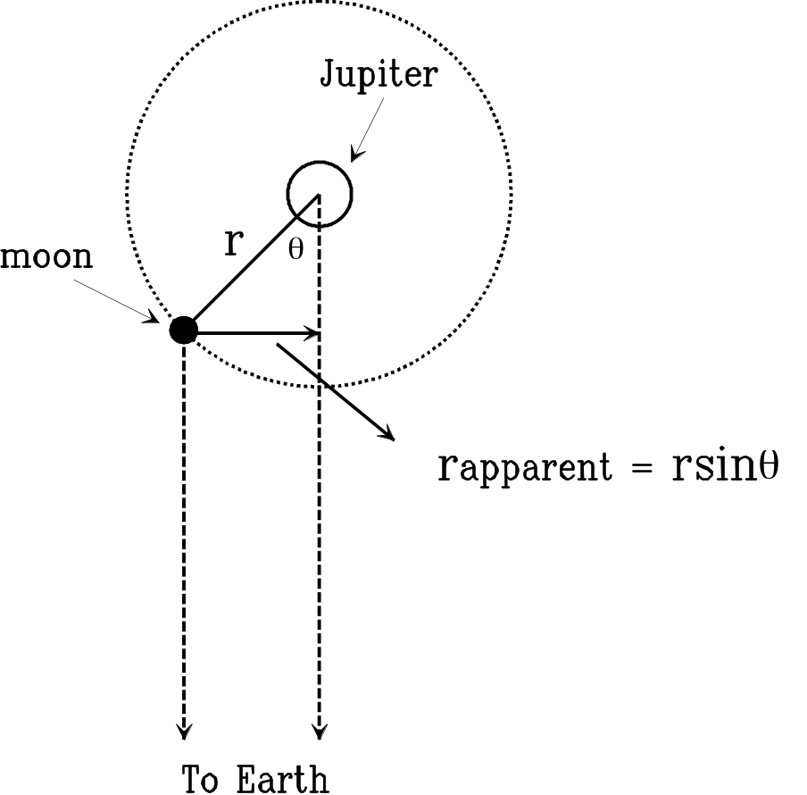
Figure 4.1: Overhead View of the Orbital Motion of a Moon around Jupiter

From this curve you can determine the moon’s orbital radius, a, and its period, T. The radius of the orbit will simply be the amplitude (i.e. the height) of the sine curve and the period of the orbit will be the distance (i.e. the number of days) between consecutive crests of the sine curve. Once you determine the orbital radius and the period of the moon you will have to convert each of these values into the appropriate units. You can calculate the mass of Jupiter by using Equation 4.1, which is a formulaic restatement of Kepler's third law. You will separately calculate Jupiter's mass for each of the four moons. As there will be errors of measurement associated with each moon, the masses that you calculate will not be exactly the same.

The Jupiter program simulates the operation of an automatically-controlled telescope with a CCD (i.e. charge-coupled device) camera that provides a video image to a computer screen. It is a sophisticated computer program that allows measurements to be conveniently made at the computer console. (You can also adjust the telescope's magnification.) The computer simulation is realistic in all important ways. Using it will give you a good feel for the way astronomers collect data and operate their telescopes. So, instead of using a telescope to actually observe the moons over a period of many days, you will use a computer simulation that will allow you to “observe” the motion of these moons over the same period of time in just a matter of minutes. The program can also show you how Jupiter and its moons would appear through a telescope at any specified date and time.

Procedure
To open the Moons of Jupiter Program: Click on Start and select All Programs-Astronomy-CLEA Exercises-Jupiter Moons. Click on File-Log In…. Type a character in one of the “Student” fields and click “OK.” When asked, “Have You Finished Logging In?” click “Yes.” The screen will show Jupiter and a few of its moons; the program should now be open.

Select File-Run… and click “Ok.” A window indicating “Start Date & Time” will appear. The date should already be set for today’s date. The “Universal Time” should be set to 0 Hour, 0 Minute, 0 Second. Click “Ok."

Select File-Preferences-Timing… to set the “Observation Interval” (i.e. the amount of time between measurements). A time interval of one day would be appropriate for Ganymede and Callisto, while an interval of only 6 hours would be appropriate for Io and Europa. (Why is this true?) Since we want to choose only one time interval to complete the lab, we will settle on an interval of 12 hours. (This may not yield the best results for the fastest or slowest orbits.) Set the interval to 12.00 Hrs, and click “Ok.” You will be measuring 24 data points for each moon (i.e. two data points per day, separated by a time interval of 12 hours, over a period of 12 consecutive days).

Before you begin taking data, open a second screen for viewing by selecting File-Preferences-Top View. This screen shows the orbits of the moons around Jupiter and the positions of the moons as would be seen from a point far above the planet. (The first screen you opened gives the edge-on view as seen from the Earth.) Although you can’t take measurements from this screen, it will provide you with a unique view of Jupiter and its moons.

Construct a data table in Excel in which to record your measurements. The table that you make should have five columns. From left to right, the column titles will be: Day, Io, Europa, Ganymede, Callisto. In the first cell under the heading in the Day column, type 0, followed by 0.5, 1.0, 1.5, 2.0, 2.5, etc., until you type 11.5 in the 25th cell. You will record your measurements in the other four columns, one row at a time, until you have taken 24 sets of 4 measurements.

To take data readings for a moon: Position the cursor over the first screen, left click and hold; the arrow will change to a cross. Move the cross until it is centered over a moon; the name of the moon will appear at the lower right of the screen. Release the button and record the perpendicular distance of the moon from the planet, which will appear below the moon’s name as “X = some number E or W [Jup. Diam.].” For example, X = 3.85W [Jup. Diam.].

Note: If the value of the perpendicular distance is followed by an E, record this distance as negative. For example, X = 7.23E [Jup. Diam.] would be recorded as -7.23.
If a moon disappears behind Jupiter, record the perpendicular distance as 0, but keep in mind that this measurement could be off by as much as 0.5 J.D. (Jupiter Diameters).

The screen can be displayed at 4 scales of magnification by clicking on the 100X, 200X, 300X, and 400X buttons at the bottom of the screen. In order to improve the accuracy of your measurements, you should use the largest magnification which leaves the moon on the screen.

When you have recorded the perpendicular distances for each moon for a particular date and time, proceed to the next screen by clicking on the “Next” button.

Note: The program is so realistic that “Cloudy Skies!” will prevent you from taking data on 2 or 3 occasions. If you encounter cloudy sky conditions, you will still need to take measurements for those days and times. So, after you finish recording your initial set of data readings—your last measurement will be taken on day 11.5—exit and then re-open the program. Proceed as before, taking data only for those days and times that were cloudy the first time. (These days and times will not be cloudy when you attempt to take readings the second time).

When you have finished taking your readings simply exit the program.

Construct a graph in Excel following a similar procedure as was done in Laboratory Exercise #1, using the data you just recorded. Plot time, in days, on the x-axis, and perpendicular distance, in units of Jupiter Diameters, on the y-axis. Make a separate, full-page graph for each of the four moons. The shape of the curves should be sinusoidal.

Examine these curves. Each represents the orbital motion of a moon. To determine the value of P (i.e. the period), count the total number of complete periods (i.e. orbits) which occurred for a moon. During the twelve-day interval over which the data was taken, some moons will have completed several orbits while one moon will not have even completed a single orbit. If a graph covers more than one period, take an average of the number of periods graphed. However, if less than a full period is graphed, take half of the period and double it, or take a quarter of the period and multiply it by four.
Once you have calculated the periods for each of the moons, convert to units of years. (See example conversions below).

Once again, examine the curves. To determine the value of a, measure the amplitude of the curve. We can consider amplitude as the average distance that the curve rises above, or falls below, the x-axis. This definition is not quite correct, but will serve our purposes.
Once you have calculated the average distance of each moon’s orbit from Jupiter, convert to AU.

On a separate sheet of paper, calculate the mass of Jupiter relative to each moon, using the converted values of a (average distance from Jupiter or more precisely, the semi-major axis) and P (orbital period), and Equation 4.1.

Show ALL work! As a point of reference, the mass of Jupiter is about 1.9 × 10²⁷ kg.

In your conclusion, explain why each moon did, or did not, give good results. Does your data indicate that Kepler's equation is conclusive for calculating mass?

Turn in your graphs, your calculations (in neat, readable form), and your response to the conclusion question.

Example Graph and Calculations
P

Figure 4.2 – Sample graph from data. The period is from one peak to the next.
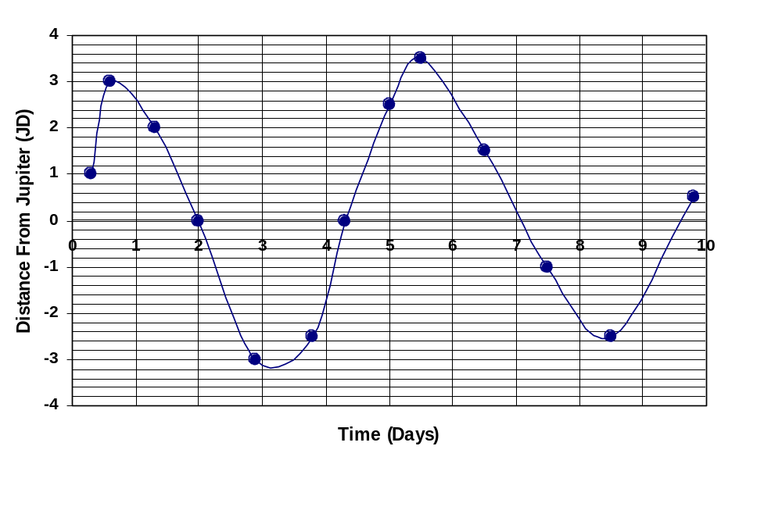

Example Calculations for Converting to Keplerian Units

P = 5 days
P = 5 days / (365days/year) = 0.014 years

a = 3.5 J.D.
a = 3.5 J.D. / (1050 J.D./AU) = 0.0033 AU

Kepler's Third Law:
M_{Jupiter} = a³ / P²

where M_{Jupiter} is the mass of Jupiter, in units of solar masses,
a is the radius of the moon’s orbit, in AU,
and P is the period of the moon’s orbit, in years.

Laboratory Exercise #5 – Optics of Cylindrical Mirrors and Lenses

Purpose: Investigate the properties of mirrors and lenses to aid in the comprehension of reflection and refraction, which is necessary to understand the way telescopes work.

Part I: Introduction
Examine the Optical Bench provided, that is, the stand for the optical components in this laboratory exercise. Open the box containing the optical components, and familiarize yourself with the various pieces of equipment contained within the box.

Setup for Ray Optics Experiment

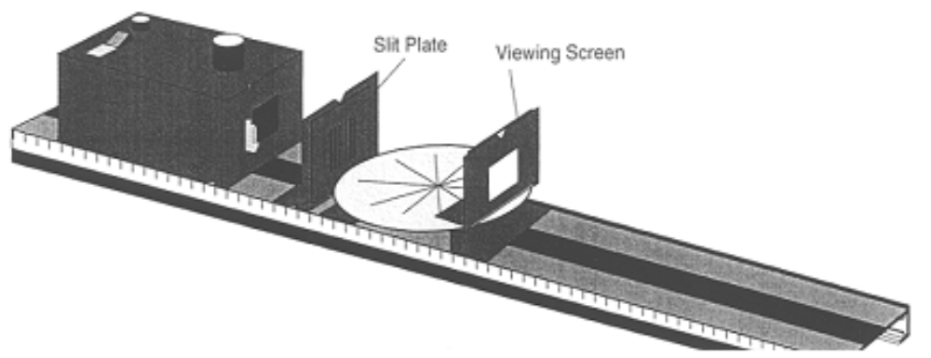

Figure 5.1
Procedure for Part I
Set up the equipment as shown in Figure 5.1. Turn on the Light Source. The room will be darkened so that the light rays will be more easily visible on the Ray Table.

Note: Remember to write the answers to all numbered questions on the Answer Sheet at the end of this write-up and turn it in to your instructor.

Observe the light rays on the Ray Table.
1.) Are the individual rays straight or curved?
2.) How do the width and distinctness (i.e. sharpness) of each ray vary with its distance from the Slit Plate? (Do not move the Slit Plate and Component Holder to answer this question.)

Set aside the Viewing Screen and Component Holder for the next step.

Lower your head until you can look along one of the rays of light on the Ray Table. Where does the light originate? What path did it take in going from its point of origin to your eye? Try this for several rays.

Replace the Viewing Screen and its Holder on the Optical Bench. Rotate the Slit Plate 90º to the left or the right. Rotate it slowly on its Component Holder, as if you were turning a knob, until the slits are horizontal. The Slit Plate should remain flush with the Component Holder and the position of the Holder should not be changed. Observe the slit images on the Viewing Screen.

3.) Describe the manner in which the width and the distinctness of the slit images change as the angle (i.e. the orientation) of the Slit Plate is changed from vertical to horizontal.

4.) Describe how the distinctness of the images varies with the slit plate angle. For what orientation of the Slit Plate are the images most distinct? For what orientation are the images least distinct?

5.) Explain your answers to question 4 in terms of the straight-line propagation of light and the orientation of the Light Bulb filament with respect to the Slit Plate. Draw a diagram illustrating how the width of a single slit image depends on the orientation of the Light Bulb filament with respect to the Slit Plate.

Ray Tracing:

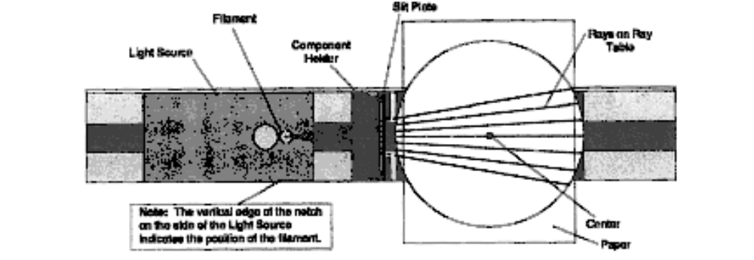

Figure 5.2: Setup for Filament Location (Top View)

You can use the fact that light propagates in a straight line to measure the distance between the Light Bulb filament and the center of the Ray Table. The rays that appear on the Ray Table originate from the Light Bulb filament of the Light Source. Since light travels in a straight line, you need only extend the rays backward to locate the position of the filament.

Get a piece of blank white paper from your instructor and fold it in half. Place the paper on the Ray Table, with the fold adjacent to the Slit Plate. (See Figure 5.2.) Make a reference mark on the paper at the position of the center of the Ray Table. Using a pencil and the Straightedge provided, trace the rays onto the paper. Make sure that the Ray Table is not too far from the light source.

Remove and unfold the paper. Use your pencil and the Straightedge to extend each of the rays back to a common point of intersection. Label the position of the filament and the center of the Ray Table on your diagram. Submit your Ray Tracing Diagram with the Answer Sheet.

Measure the distance between your reference mark and the point of intersection of the rays. Label this distance M₁.

Use the metric scale on the side of the Optical Bench if one is available, otherwise use a ruler to measure the distance between the filament and the center of the Ray Table directly. Use Figure 5.2 as a guide. Label this distance M₂.

6.) What is the difference between M₁ and M₂? Explain why the two measurements should, or should not, be different?

One of the concepts that this experiment illustrates is that light rays can be traced to their (apparent) origin. This concept will prove most useful in the following experiments.

Procedure for Part II, Cylindrical Mirrors

The ray tracing technique can be used to locate the image formed by the reflection of light rays from any mirrored surface. Think of the object to be reflected as a collection of point sources of light. For a given point source, light rays diverging from it are reflected from the surface of the mirror according to the Law of Reflection. This law states that the angle of the incident (i.e. incoming) ray is equal to the angle of the reflected ray. The angle is measured with respect to a line that is perpendicular to the reflecting surface at the point of incidence. If the reflected rays intersect at a point, then a real image is formed at that point. That point is the focal point. However, if the reflected rays diverge (i.e. spread out), then a virtual image will be formed behind the plane of the mirror. The position of this image can be found by extending the reflected rays back behind the surface of the mirror. The virtual image will appear to be located at the point where the extended rays cross.

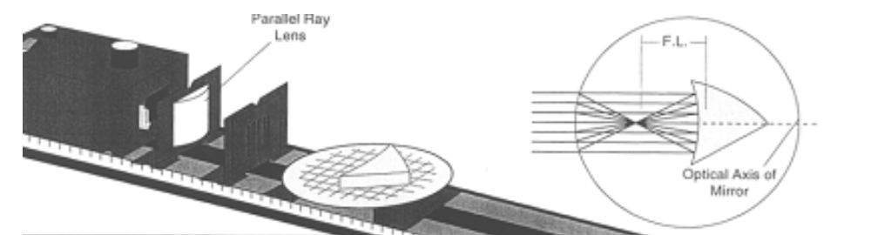

Figure 5.3: Setup for Cylindrical Mirror Experiment

In this experiment you will use the Ray Table to examine the properties of image formation from a mirrored cylindrical surface. The properties you will observe have important analogs in image formation from concave mirrors that are found in some optical (i.e. reflecting) telescopes.

Procedure for Part III, Determining Focal Lengths

Set up the equipment as shown in Figure 5.3. Position the Ray Optics Mirror on the Ray Table so that all of the incident rays are reflected from the concave surface of the Mirror.

Adjust the position of the Parallel Ray Lens (i.e. Move the Lens and Component Holder forward or back along the Optical Bench) to obtain parallel rays on the Ray Table. Adjust the position of the Mirror on the Ray Table until the incident rays are parallel to the optical axis of the Mirror. (See circular inset diagram in Figure 5.3.)

7.) Measure F.L._{mirror}, the focal length of the Ray Optics Mirror. (The focal length is the distance between the middle of the surface of the mirror and the focal point.)

F.L._{mirror} = ____________________

Part III: Cylindrical Lens
You have investigated image formation through the principle of reflection. The principles at work in image formation through refraction are analogous, therefore similar ray tracing techniques can be used to determine the location of the image. The Law of Refraction replaces the Law of Reflection in determining the change in direction of the incident rays. Refraction refers to the change in propagation direction of a light ray when it passes from air to a denser medium, such as glass, or when it passes from a relatively denser medium to air. Therefore, the bending of light rays takes place at two surfaces, as the ray passes into, and then out of, the lens.

In this experiment, you will use the Ray Table to examine the properties of image formation using cylindrical lenses. The properties you will observe have important analogs in image formation for spherical lenses that are found in some optical (i.e. refracting) telescopes.

Procedure for Part IV, Cylindrical Lenses

Set up the equipment as shown in Figure 5.4. Position the Cylindrical Lens on the Ray Table so that all of the incident rays hit the flat surface of the lens.

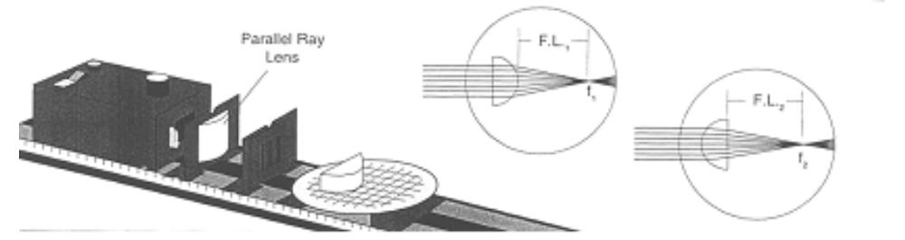

Figure 5.4: Setup for Cylindrical Lens Experiment

8.) Adjust the position of the Parallel Ray Lens as before to obtain parallel rays on the Ray Table. Adjust the Cylindrical Lens so that its flat surface is perpendicular to the incident rays and the central ray passes through the Lens without being bent. Note the circular inset diagram in Figure 5.4.

a.) Measure F.L._{1.}

F.L.₁ = ____________________

b.) Rotate the Cylindrical Lens 180º and measure F.L.₂. (See circular inset diagram in Figure 5.4.)

F.L.₂ = ____________________

9.) Remove the Parallel Ray Lens and Component Holder. Remove the Slit Plate from its Component Holder. Set the Holder aside and place the Slit Plate directly on the front of the Light Source. Move the Ray Table and Base close enough to the Light Source so that the curved side of the Cylindrical Lens can be positioned a distance F.L.₁ from the Light Bulb filament. Describe the refracted rays.

10.) Rotate the Cylindrical Lens 180º and place it on the Ray Table so that its straight side is a distance F.L.₂ from the Light Bulb filament. Describe the refracted rays.

Answer Sheet
To be submitted to your lab instructor.

1.) Are the individual rays straight or curved?

2.) How do the width and distinctness (i.e. sharpness) of each ray vary with its distance from the Slit Plate?

3.) Describe the manner in which the width and the distinctness of the slit images change as the angle (i.e. the orientation) of the Slit Plate is changed from vertical to horizontal.

4.) Describe how the distinctness of the images varies with the slit plate angle. For what orientation of the Slit Plate are the images most distinct? For what orientation are the images least distinct?

5.) Explain your answers in question 4 in terms of the straight-line propagation of light and the orientation of the Light Bulb filament with respect to the Slit Plate. Draw a diagram illustrating how the width of a single slit image depends on the orientation of the Light Bulb filament with respect to the Slit Plate.

6.) What is the difference between M₁ and M₂? Explain why the two measurements should, or should not, be different?

7.) Measure F.L._{mirror}, the focal length of the Ray Optics Mirror.

F.L._{mirror} = ____________________

8a.) Measure F.L._{1.}

F.L.₁ = ____________________

8b.) Measure F.L.₂.

F.L.₂ = ____________________

9.) Describe the refracted rays.

10.) Describe the refracted rays.

Conclusion:

Laboratory Exercise #6 – The Retrograde Motion of Mars

Purpose: Investigate the motion of Mars as seen in the sky throughout a year, especially noting the retrograde motion, using planetarium type simulation software that provides a view of the sky for any day of the year, at any location.

Introduction: Superior Planets
Planets whose orbits lie outside the orbit of the Earth are called superior planets. These include the three naked-eye planets of Mars, Jupiter, and Saturn, and the three telescopic planets of Uranus, Neptune, and Pluto.

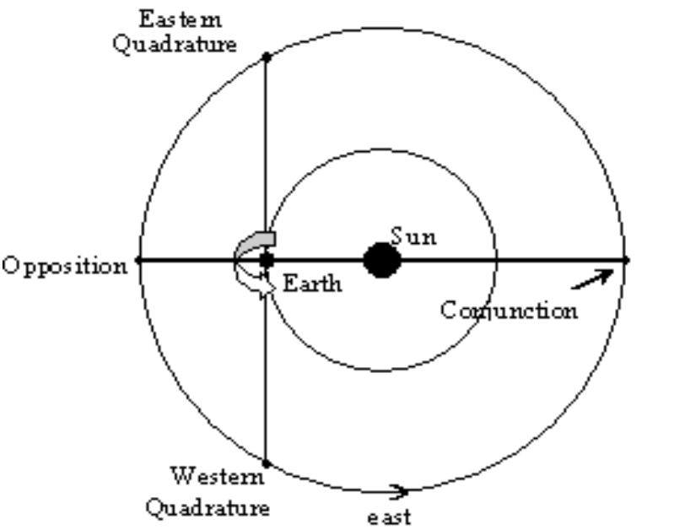

Figure 6.1: The Four Planetary Configurations of a Superior Planet

When a superior planet is on the opposite side of the Earth with respect to the Sun, it is said to be in opposition. At that time, the planet is also as close to the Earth as it will come, and as bright in the night sky as it will appear, until the time of the next opposition approaches. When a planet is in opposition it is visible throughout the night because it rises at sunset.

As a superior planet continues in its orbit—keep in mind that the Earth is moving in its orbit as well—it will soon reach a point that is 90º east of the Sun with respect to the Earth-Sun line, an imaginary line joining the Earth to the Sun. At this point it is in eastern quadrature. This is the planetary configuration that follows opposition. Here the planet will rise at noon and will appear as an “evening star” in the night sky.

As a superior planet continues in its orbit from eastern quadrature, its apparent angular distance from the Sun, known as its elongation, will decrease. This means that the planet is approaching the position of the Sun in the sky, as viewed from the Earth. The planet will eventually arrive at a configuration known as conjunction. At this point it will again be aligned with the Earth and the Sun, as it was in opposition, but now it will be positioned on the other side of the Sun. Here the planet will rise and set in “conjunction” with the Sun.

After conjunction a superior planet passes through to western quadrature, a point in its orbit that is 90º west of the Earth-Sun line. When the planet is in this configuration, it will rise at midnight and will appear in the sky as a “morning star.” Finally, the superior planet will return to opposition, its cycle of configurations complete.

Look at Figure 6.1 and consider the following: The planets orbit the Sun in a counterclockwise direction, as viewed from a point above the solar system. Why is it that a superior planet will proceed to eastern quadrature, and not western quadrature, following opposition?

Retrograde Motion
As the orbital velocity of the Earth is greater than that of a superior planet, the Earth will overtake and pass a superior planet at some point during their respective orbits. This will occur as the planet's configuration is changing from western quadrature through opposition to eastern quadrature. (From eastern quadrature through conjunction to western quadrature, the planet exhibits its normal eastward motion relative to the background stars.) During this period of passing, the superior planet will appear to temporarily interrupt its normal eastward motion, known as direct motion, and move westward. This counter-motion is known as retrograde motion, during which time the superior planet will appear to trace either a closed loop or a figure-S against the background stars. The planet will appear to slow as the period of retrograde is coming to a close. It will then resume its usual eastward path in the sky.

You can better understand retrograde motion by considering the following example from your everyday experience. Picture yourself driving in a car on the highway. You are about to overtake a slower-moving vehicle and you can observe this car relative to the distant horizon ahead of you. At first this car appears to be moving forward relative to the horizon, but as you begin to pass, the car appears to slow to a stop. As you pass this car it then appears to be moving backward, despite the fact that it is moving forward at a high rate of speed! Once you are well past the car, it again appears to be moving forward, but now relative to the horizon behind you.

Since the Earth orbits the Sun more swiftly than Mars does, it will overtake the Red Planet as described above, every 26 months or so. As Earth passes, Mars will appear to reverse its motion relative to the background stars until the Earth is well past it, at which time Mars will resume its “normal” eastward motion relative to the background stars.

Note: Only the superior planets can be in opposition, and exhibit retrograde motion. However, Mercury and Venus exhibit a cycle of phases like our Moon, which is unique to the inferior planets.

Let’s state the question: How can we go about finding the period of time in which Mars will be in retrograde motion, and the date that Mars will be in opposition, for the year 2005?

Make a prediction as to ‘how’ this question could be answered: Describe the procedure (including any needed tools) that you would follow in order to “see” Mars exhibiting retrograde motion, assuming the planet was visible at night from your location.

Starry Night Program Usage:
-Open Starry Night. Take a few minutes to familiarize yourself with the workings of this program. Play with the buttons and find out what this program can do!

-Below you will find instructions to set the Starry Night program to track the path of Mars against the background stars.

Part I

-Change the date to January 1, 2005.

-Set the time interval to “1 days.” The default setting in the Time Interval window is 1×. (In this mode the rate of time flow is the same as real time.) Access the pull-down menu—click on the inverted black caret in the blue square—and select “days.”

-Open the Find pane at the top of the left margin of the screen. Click on the Mars box, then access the Mars “contextual” menu (by clicking on the inverted black caret, etc.) and select:

“Celestial Path”
“Centre”

-After selecting “Centre,” if the program indicates that “Mars is currently not visible from your location,” click on “Hide Horizon.”

-Click on View, in the menu at the top left of the screen, and select “White Sky.”

-Click on the Time Forward arrow to set the program in motion. (The Time Forward arrow is located to the right of the Time Interval window. It is the black right-facing triangle, next to the black square.) After Mars has completely traced out its retrograde path (i.e. a loop or a figure-S), stop the program by clicking on the black square to the left of the Time Forward arrow. Zoom in on the retrograde portion of the orbital tracing. (Use the Magnifying Glass icons or the slider button in the “Field of View” control panel at the top right of the screen.) Print the screen.

-Mark with an X the position of Mars at opposition and indicate the date. Also, label the points where retrograde motion begins and ends—these are called stationary points—with a B and an E, respectively. Indicate the dates at these points as well.

Part II

-Click on Go in the menu (top left) , select “Solar System,” and click on “Inner Solarsystem.”

-Access the pull-down menu in the upper left corner to change the “Hand” cursor icon to the “Location Scroller” cursor icon. The “Location Scroller” can be used to change the orientation of the inner solar system from an “edge-on” view to a “top” view.

-Re-set the date to January 1, 2005, and set the program in motion as you did before.

-Stop the program when the Sun, the Earth, and Mars are aligned, in that order. This alignment illustrates Mars in opposition. Note the date of alignment and provide it as the second date of opposition required on your lab answer sheet. Print this screen.

-Submit your print-outs from Part I and Part II with your lab answer sheet.

How can you be sure your date is accurate? After completing the lab, search the Web to find the date of opposition.

- What search engine did you use?
- What search-wording sequence gave the desired result?
- What is the exact date of Opposition for 2005?
- How close were the dates that you determined from your print-outs to the published date that you found on the web?
- Give the URL for the website.

Answer Sheet
To be submitted to your lab instructor.

Describe the procedure (including any needed tools) that you would follow in order to “see” Mars exhibiting retrograde motion, assuming the planet was visible at night from your location.

Dates of Retrograde Motion from Part I print-out: _________________________ to _________________________

Date of Opposition from Part I print-out: _________________________

Date of Opposition from Part II print-out: _________________________

Find an ideal latitude and longitude (i.e. an ideal location on Earth) from which one could observe the entire period of Mars in retrograde at 10 PM EST.

What search engine did you use?

What search-wording sequence gave the desired result?

What is the exact date of Opposition for 2005?

How close were the dates that you determined from your print-outs to the published date that you found on the web?

Give the URL for the website.

Conclusion:

